

SIMATS ENGINEERING

Saveetha Institute of Medical and Technical Sciences
Chennai- 602105

Student Name: GUNAVATHI A Reg. No:192511374
Course Code: CSA0509 Slot: A
Course Name: Database Management systems
Course Faculty: Dr.R.Kesavan
Project Title: Smart Water Utility Consumption, Billing, and Complaint Management System: An Integrated Study in File Organization,Indexing, Hashing, Query Optimization, and Transaction
Management
Module Photographs: (3 photographs –Module Photo, Individual student contribution module work in the project and presentation image)
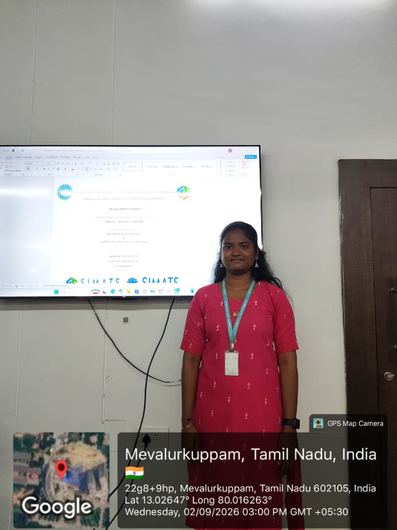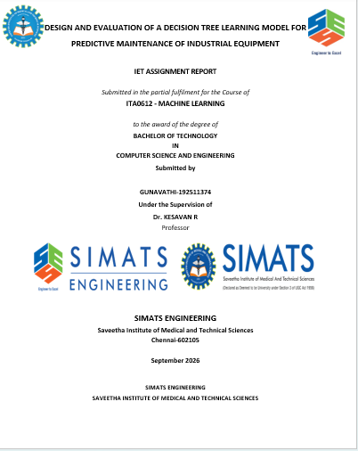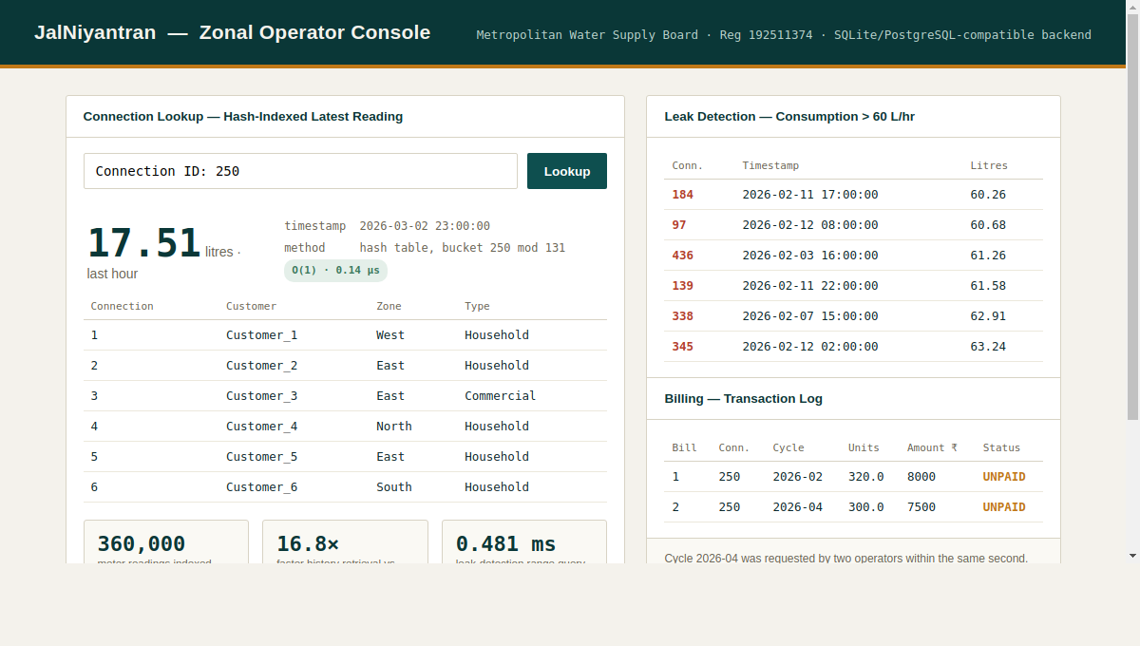
Project Description: (here you write what you did in this project (contribution) including Model Description
Our solution is a Smart Water Utility Consumption, Billing, and Complaint Management System developed to improve the efficiency and reliability of water utility services. The system manages customer connections, meter readings, billing, payments, and complaint records in an integrated database. We implemented optimized SQL queries and indexing techniques to improve the speed of data retrieval and leak detection. The solution uses transaction management with SAVEPOINT and rollback mechanisms to ensure that billing operations are completed safely without partial data. Concurrency control is also implemented to prevent duplicate bills and lost updates when multiple operators access the system at the same time. A unique constraint ensures that only one bill is generated for a customer in a particular billing cycle. The system also includes an operator dashboard for monitoring important information and transaction results. Overall, our solution improves data accuracy, query performance, security, reliability, and customer trust, providing an efficient database-based solution for modern water utility management.

Student Signature Guide Signature

